**Topic**

**Weather Analysis**

* **Introduction** :-
* Weather plays a vital role in our daily lives, influencing everything from the clothes we wear to the activities we plan. Understanding weather patterns and trends is essential for various sectors including agriculture, transportation, and public safety. This weather analysis project aims to investigate and interpret the weather conditions observed over a specific period in [Insert Location]. By collecting and analyzing data on temperature, humidity, wind speed, and precipitation, this project will identify significant weather patterns and anomalies. The insights gained from this analysis will not only enhance our understanding of local climatic conditions but also aid in predicting future weather events more accurately. Through this comprehensive study, we hope to contribute valuable information that can be utilized for better planning and preparedness in our community.
* **Objective**:-

This project focuses on weather analysis, utilizing historical and real-time data to explore trends, identify anomalies, and make forecasts. The study involves examining parameters such as temperature, humidity, precipitation, and wind speed across different regions and time frames. By leveraging data analysis tools and techniques, the project aims to uncover insights that can support decision-making processes in fields like disaster management, energy planning, and urban development. Weather patterns has become an essential task for predicting future trends and understanding environmental changes**.**

* **Overview :-**The goal of this project is to analyze weather data to identify trends, uncover patterns, and provide actionable insights for better decision-making in weather-related scenarios. By collecting and analyzing data on key weather parameters such as temperature, humidity, wind speed, and precipitation, this project seeks to identify significant patterns and anomalies. The analysis will help in understanding the local climatic conditions and their impact on various sectors such as agriculture, transportation, and public safety. This study focuses on leveraging data analytics tools—Excel, SQL, and Power BI—for efficient data processing, analysis, and visualization.
* **Data Sources :-**The data for this project includes historical and real-time weather data, sourced from repositories and some from other sources. Key parameters analyzed include temperature, precipitation, humidity, wind speed, and weather conditions over specified regions and time periods.

**DATA TABLES** :-

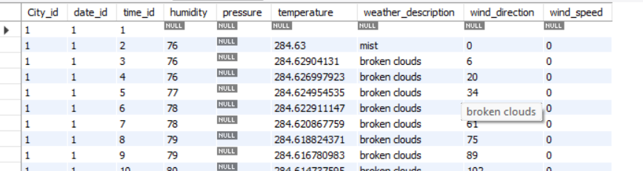

This is the table I am using for solving some of weather releted question. Thie table shows information about pressure, temperature, weather description, wind diorection, wind speed and humidity of the cities in a different country.

* **Tools and Technologies :-**

**SQL**: Utilized to store, query, and manipulate large datasets.

Wrote complex queries to extract specific weather insights and optimize data processing.

1 Are there any countries with cities located at extreme latitudes, and how might this impact their climate?

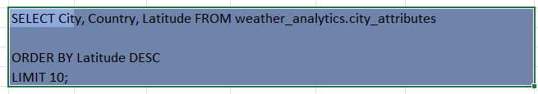

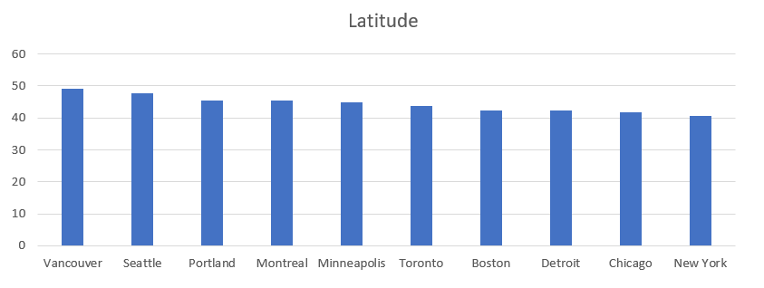

Above bar chart is showing the latitude in a particular country and city.

2 Can you identify any clusters of cities with similar latitude and longitude values? What factors might explain these clusters?

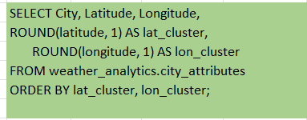

|  |  |  |  |  |
| --- | --- | --- | --- | --- |
| **City** | **Latitude** | **Longitude** | **lat_cluster** | **lon_cluster** |
| Miami | 25.774269 | -80.193657 | 25.8 | -80.2 |
| San Antonio | 29.42412 | -98.493629 | 29.4 | -98.5 |
| Eilat | 29.55805 | 34.948212 | 29.6 | 34.9 |
| Houston | 29.763281 | -95.363274 | 29.8 | -95.4 |
| Jacksonville | 30.33218 | -81.655647 | 30.3 | -81.7 |
| Beersheba | 31.25181 | 34.791302 | 31.3 | 34.8 |
| Jerusalem | 31.769039 | 35.216331 | 31.8 | 35.2 |
| Tel Aviv District | 32.083328 | 34.799999 | 32.1 | 34.8 |
| San Diego | 32.715328 | -117.15726 | 32.7 | -117.2 |
| Dallas | 32.783058 | -96.806671 | 32.8 | -96.8 |
| Haifa | 32.815559 | 34.98917 | 32.8 | 35 |

The above table is showing the clusters in a particular cities. In above table we can see that there is latitude cluster and longitude cluster formed in the city is different for all city.

3 Are there any correlations between a city's geographical location (latitude and longitude) and its weather attributes, such as temperature or humidity?

|  |  |  |
| --- | --- | --- |
| select cl.City as city_names, | |  |
| ca.Latitude, |  |  |
| ca.Longitude, |  |  |
| f.humidity, |  |  |
| f.temperature |  |  |
| from city_attributes ca | |  |
| inner join city_lookup cl ON ca.City_id = cl.City_id | | |
| inner join final_fact f ON cl.City_id = f.City_id | | |

|  |  |  |  |  |
| --- | --- | --- | --- | --- |
| **city_names** | **Latitude** | **Longitude** | **Humidity** | **Temperature** |
| Vancouver | 49.24966 | -123.119339 |  |  |
| Vancouver | 49.24966 | -123.119339 | 76 | 284.63 |
| Vancouver | 49.24966 | -123.119339 | 76 | 284.6290413 |
| Vancouver | 49.24966 | -123.119339 | 76 | 284.6269979 |
| Vancouver | 49.24966 | -123.119339 | 77 | 284.6249545 |
| Vancouver | 49.24966 | -123.119339 | 78 | 284.6229111 |
| Vancouver | 49.24966 | -123.119339 | 78 | 284.6208678 |
| Vancouver | 49.24966 | -123.119339 | 79 | 284.6188244 |

The above table is showimg the all weather conditions that are in citis.

4 Identify the top three cities with the most frequent occurrence of rainy weather based on weather descriptions. What are the seasonal patterns?

|  |  |  |  |  |  |  |  |  |  |  |
| --- | --- | --- | --- | --- | --- | --- | --- | --- | --- | --- |
| WITH cte AS ( | |  | |  |  | |  | |  | |
| SELECT |  |  | |  |  | |  | |  | |
| c.City, | |  | |  |  | |  | |  | |
| f.weather_description, | | | |  |  | |  | |  | |
| COUNT(f.City_id) AS weather_count, | | | | |  | |  | |  | |
| DENSE_RANK() OVER(PARTITION BY c.City ORDER BY COUNT(f.City_id) DESC) AS RN | | | | | | | | | | |
| FROM final_fact f | |  | |  |  | |  | |  | |
| JOIN city_lookup c ON f.City_id = c.City_id | | | | |  | |  | |  | |
| WHERE f.weather_description LIKE '%rain%' | | | | |  | |  | |  | |
| GROUP BY c.City, f.weather_description | | | | |  | |  | |  | |
| ) |  |  | |  |  | |  | |  | |
| SELECT * |  |  | |  |  | |  | |  | |
| FROM cte |  |  | |  |  | |  | |  | |
| WHERE RN = 1 | |  | |  |  | |  | |  | |
| LIMIT 3 |  |  | |  |  | |  | |  | |
| **City** | | | **weather_description** | | | **weather_count** | | **RN** | |
| Albuquerque | | | light rain | | | 2087 | | 1 | |
| Atlanta | | | light rain | | | 3784 | | 1 | |
| Beersheba | | | light rain | | | 3545 | | 1 | |

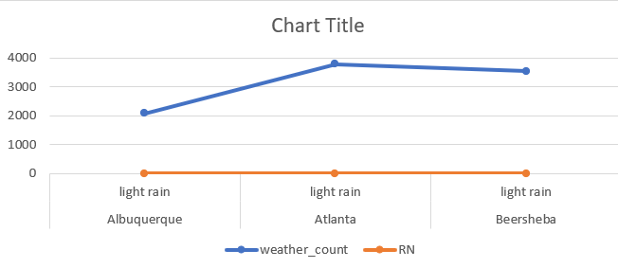

This chart is showing the type of rain in the different cities. Also gives information of which type of rain are there like light rain, high rain and moderate. But according to the this chart there are mostly light rain is present most of the cities.

5 Is there a correlation between humidity levels and air pressure? How might this relationship affect weather conditions?

|  |  |  |  |  |
| --- | --- | --- | --- | --- |
| select |  |  |  |  |
| AVG(humidity) as avg_humidity, | | |  |  |
| AVG(pressure) as avg_pressure, | | |  |  |
| count(*) as total_records | | |  |  |
| from final_fact | |  |  |  |
| where humidity IS NOT NULL AND pressure IS NOT NULL; | | | | |
|  |  |  |  |  |

|  |  |  |
| --- | --- | --- |
| **avg_humidity** | **avg_pressure** | **total_records** |
| 68.12447523 | 1016.525115 | 1596414 |

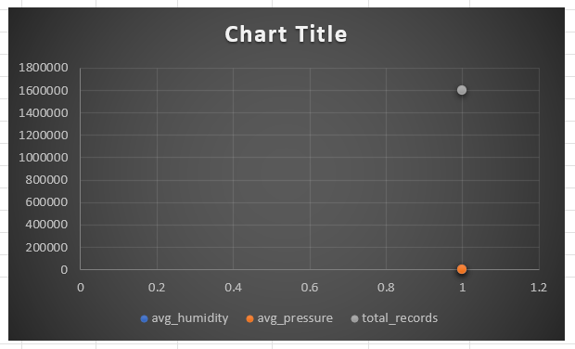

6. Explore the impact of wind direction on temperature for coastal cities. Are there noticeable patterns?

|  |  |  |  |  |  |
| --- | --- | --- | --- | --- | --- |
| WITH cte AS ( | |  |  |  |  |
| SELECT |  |  |  |  |  |
| c.City, | |  |  |  |  |
| f.wind_direction, | |  |  |  |  |
| AVG(f.temperature) AS avg_temperature, | | | |  |  |
| COUNT(f.City_id) AS city_counts, | | | |  |  |
| DENSE_RANK() OVER (PARTITION BY c.City ORDER BY COUNT(f.City_id) DESC) AS dr | | | | | |
| FROM |  |  |  |  |  |
| final_fact f | |  |  |  |  |
| JOIN |  |  |  |  |  |
| city_lookup c ON f.City_id = c.City_id | | | |  |  |
| WHERE | |  |  |  |  |
| f.temperature IS NOT NULL | | |  |  |  |
| AND f.wind_direction IS NOT NULL | | | |  |  |
| GROUP BY | |  |  |  |  |
| c.City, f.wind_direction | | |  |  |  |
| ) |  |  |  |  |  |
| SELECT * |  |  |  |  |  |
| FROM cte |  |  |  |  |  |
| WHERE dr = 1; | |  |  |  |  |
|  | |  |  |  |  |

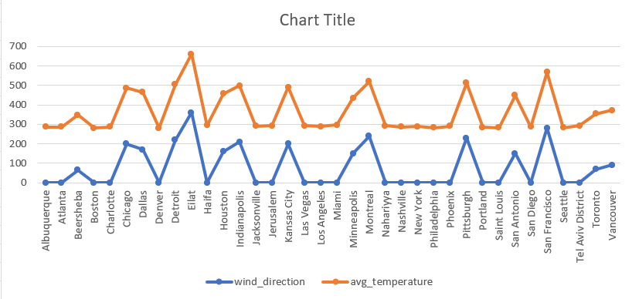

7. Are there specific months when cities experience significant temperature fluctuations? What might explain these variations?

|  |  |  |  |  |
| --- | --- | --- | --- | --- |
| SELECT |  |  |  |  |
| c.City, |  |  |  |  |
| MONTH(d.date) AS month, | | |  |  |
| AVG(f.temperature) AS avg_temperature, | | | |  |
| MAX(f.temperature) - MIN(f.temperature) AS temp_fluctuation | | | | |
| FROM |  |  |  |  |
| final_fact f | |  |  |  |
| join city_lookup c ON f.City_id = c.City_id | | | |  |
| join date_lookup d ON f.date_id = d.date_id | | | |  |
| WHERE |  |  |  |  |
| f.temperature IS NOT NULL | | |  |  |
| GROUP BY | |  |  |  |
| c.City, MONTH(d.date) | | |  |  |
| ORDER BY | |  |  |  |
| temp_fluctuation DESC | | |  |  |
| limit 20; |  |  |  |  |

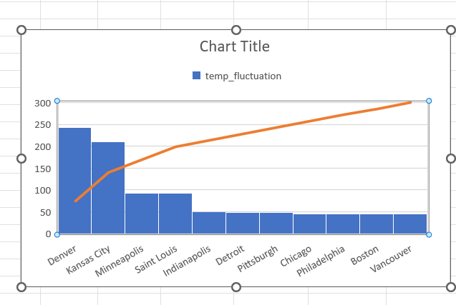

This above temp_fluctuation chart shows the fluctuation in temperature in different ciies. It give us idea about temperature so that according to that we can set our mind. This chart appears to combine a **bar chart** and a **line chart**, representing data related to "temp_fluctuation" across several cities.

**High Fluctuation:** Denver shows the highest "temp_fluctuation."

**Low Fluctuation:** Cities like Boston and Vancouver exhibit minimal fluctuation.

The orange line demonstrates an increasing trend, indicating a steady rise across the cities.

8. Identify periods of extreme weather events, such as storms or heatwaves, by analyzing the time-based data. What patterns emerge?

|  |  |  |  |  |
| --- | --- | --- | --- | --- |
| **It is depend on storms and wind_speed >30** | | | | |
|  |  |  |  |  |
| SELECT f.City_id, | |  |  |  |
| f.date_id, | |  |  |  |
| t.time_id, | |  |  |  |
| f.weather_description, | | |  |  |
| f.wind_speed | |  |  |  |
| FROM final_fact f | |  |  |  |
| join time_lookup t ON f.time_id = t.time_id | | | |  |
| where weather_description like '%storm%' OR wind_speed > 30 | | | | |
| order by wind_speed DESC | | |  |  |
| limit 20; |  |  |  |  |

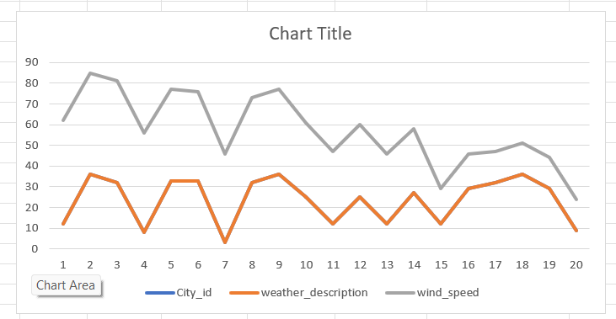

|  |  |  |  |
| --- | --- | --- | --- |
| **based on temperature > 300** | | | |
|  |  |  |  |
| SELECT f.City_id, | |  |  |
| f.date_id, | |  |  |
| t.time_id, | |  |  |
| f.temperature | |  |  |
| FROM final_fact f | |  |  |
| join time_lookup t ON f.time_id = t.time_id | | | |
| where f.temperature > 300 | | |  |
| limit 20; |  |  |  |
|  |  |  |  |

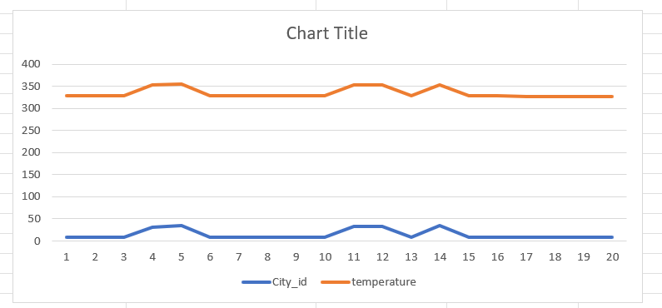

9. Are there any notable differences in temperature trends between northern and southern hemisphere cities over the year? How do they relate to seasons?

|  |  |  |  |  |  |  |  |
| --- | --- | --- | --- | --- | --- | --- | --- |
|  | | |  | | |  | |
| **Monthly average Temperature** | | | | |  | |
|  |  |  | |  |  | |
|  |  |  | |  |  | |
| WITH hemisphere_data AS ( | | | |  |  | |
| SELECT ct.City_id, | |  | |  |  | |
| CASE | |  | |  |  | |
| WHEN latitude > 0 THEN 'Northern Hemisphere' | | | | | | |
| ELSE 'Southern Hemisphere' | | | |  |  | |
| END AS hemisphere, | | | |  |  | |
| EXTRACT(MONTH FROM f.date_id) AS month, | | | | | | |
| f.temperature - 273.15 AS temperature_celsius | | | | | | |
| FROM final_fact f | |  | |  |  | |
| join city_attributes ct ON f.City_id = ct.City_id | | | | |  | |
| ) |  |  | |  |  | |
| SELECT hemisphere, month, | | | |  |  | |
| AVG(temperature_celsius) AS avg_temperature | | | | |  | |
| FROM hemisphere_data | | | |  |  | |
| GROUP BY hemisphere, month | | | |  |  | |
| ORDER BY hemisphere, month; | | | |  |  | |

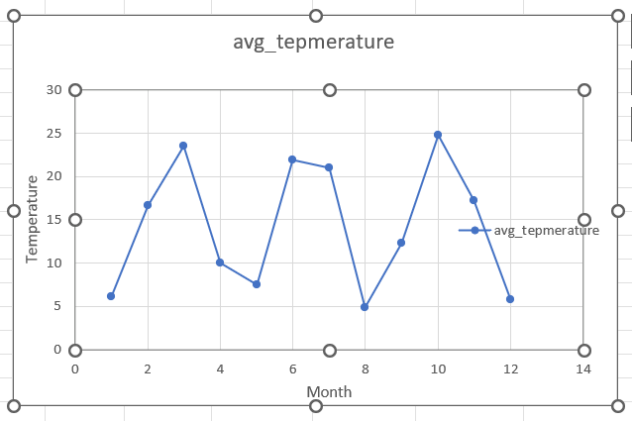

10. What are the consequences of prolonged periods of extreme cold or heat in specific cities? How do residents adapt to such conditions?

|  |  |  |  |
| --- | --- | --- | --- |
| SELECT c.City, | |  |  |
| COUNT(*) AS consecutive_days, | | |  |
| MIN(f.date_id) AS start_date, | | |  |
| MAX(f.date_id) AS end_date, | | |  |
| AVG(f.temperature) AS avg_temp | | |  |
| FROM final_fact f | |  |  |
| join city_lookup c ON f.City_id = c.City_id | | | |
| WHERE f.temperature > 40 or f.temperature < -10 | | | |
| GROUP BY c.City , f.date_id | | |  |
| HAVING COUNT(*) >= 7 | | |  |
| ORDER BY c.City , start_date | | |  |
| limit 20; |  |  |  |
|  |  |  |  |
|  |  |  |  |

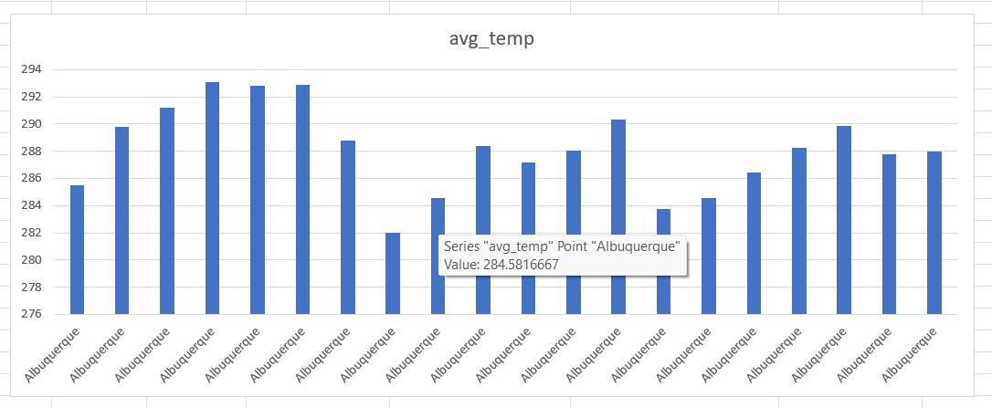

11. Investigate whether temperature anomalies (unusual deviations from the norm) coincide with certain events or environmental factors in specific cities.

|  |  |  |  |  |  |
| --- | --- | --- | --- | --- | --- |
| CREATE TABLE city_date_avg_temp AS | | | |  |  |
| SELECT |  |  |  |  |  |
| City_id, |  |  |  |  |  |
| date_id, | |  |  |  |  |
| AVG(temperature) AS avg_temperature | | | |  |  |
| FROM |  |  |  |  |  |
| final_fact | |  |  |  |  |
| GROUP BY | |  |  |  |  |
| City_id, date_id; | |  |  |  |  |
|  |  |  |  |  |  |
| SELECT |  |  |  |  |  |
| f.City_id, | |  |  |  |  |
| f.date_id, | |  |  |  |  |
| f.time_id, | |  |  |  |  |
| f.temperature, | |  |  |  |  |
| f.weather_description, | | |  |  |  |
| f.humidity, | |  |  |  |  |
| f.wind_direction, | |  |  |  |  |
| f.wind_speed, | |  |  |  |  |
| CASE |  |  |  |  |  |
| WHEN f.temperature > c.avg_temperature + 5 THEN 'High Anomaly' | | | | | |
| WHEN f.temperature < c.avg_temperature - 5 THEN 'Low Anomaly' | | | | | |
| ELSE 'Normal' | |  |  |  |  |
| END AS anomaly_flag | | |  |  |  |
| FROM |  |  |  |  |  |
| final_fact f | |  |  |  |  |
| JOIN |  |  |  |  |  |
| city_date_avg_temp c ON f.City_id = c.City_id AND f.date_id = c.date_id | | | | | |
| WHERE |  |  |  |  |  |
| f.weather_description IN ('mist', 'broken clouds', 'storm') | | | | |  |
| ORDER BY | |  |  |  |  |
| f.City_id, f.date_id, f.time_id; | | |  |  |  |

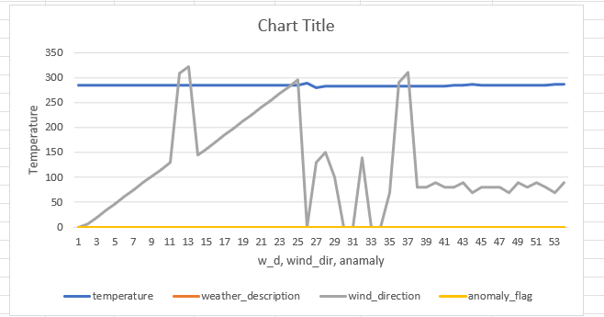

12. Analyze the impact of temperature on energy consumption patterns in cities. Are there noticeable trends or correlations?

|  |  |  |  |  |  |  |
| --- | --- | --- | --- | --- | --- | --- |
| SELECT |  |  |  |  |  |  |
| City, |  |  |  |  |  |  |
| AVG(Temperature_C) AS avg_temperature, | | |  |  |  |  |
| AVG(Energy_Usage_KWh) AS avg_energy_usage, | | |  |  |  |  |
| (SUM((Temperature_C - (SELECT AVG(Temperature_C) FROM city_energy_consumption AS t2 WHERE t2.City = t1.City)) * | | | | | | |
| (Energy_Usage_KWh - (SELECT AVG(Energy_Usage_KWh) FROM city_energy_consumption AS t2 WHERE t2.City = t1.City))) / | | | | | | |
| (COUNT(*) * STD(Temperature_C) * STD(Energy_Usage_KWh))) AS temp_energy_correlation | | | | | |  |
| FROM |  |  |  |  |  |  |
| city_energy_consumption AS t1 | |  |  |  |  |  |
| GROUP BY |  |  |  |  |  |  |
| City |  |  |  |  |  |  |
| ORDER BY |  |  |  |  |  |  |
| temp_energy_correlation DESC; | |  |  |  |  |  |

|  |  |  |  |
| --- | --- | --- | --- |
| **City** | **avg_temperature** | **avg_energy_usage** | **temp_energy_correlation** |
| Vancouver | 13.5 | 1400 | 1 |
| Portland | 16 | 1250 | 1 |
| San Francisco | 14 | 1750 | 1 |
| Seattle | 13 | 1225 | 1 |
| Los Angeles | 22.5 | 2650 | 1 |
| San Diego | 24.5 | 2750 | 1 |
| Las Vegas | 26 | 2950 | 1 |
| Phoenix | 26 | 3050 | 1 |
| Albuquerque | 23 | 2700 | 1 |
| Denver | 13 | 1550 | 1 |
| San Antonio | 24.5 | 2700 | 1 |

13. How do specific wind patterns impact air quality and pollution dispersion in urban areas? Analyze wind direction data for insights.

|  |  |  |  |
| --- | --- | --- | --- |
| SELECT c.City, |  |  |  |
| f.weather_description, | |  |  |
| f.wind_direction, |  |  |  |
| AVG(f.wind_speed) AS avg_wind_speed, | | |  |
| COUNT(*) AS count | |  |  |
| FROM final_fact f |  |  |  |
| join city_lookup c ON f.City_id = c.City_id | | |  |
| WHERE weather_description IS NOT NULL | | |  |
| GROUP BY f.weather_description, wind_direction,c.City | | | |
| ORDER BY f.weather_description, avg_wind_speed DESC; | | | |

|  |  |  |  |  |
| --- | --- | --- | --- | --- |
| **City** | **weather_description** | **wind_direction** | **avg_wind_speed** | **count** |
| Indianapolis | broken clouds | 345 | 11 | 1 |
| Saint Louis | broken clouds | 305 | 10 | 1 |
| Nahariyya | broken clouds | 196 | 10 | 3 |
| Tel Aviv District | broken clouds | 288 | 10 | 3 |
| Tel Aviv District | broken clouds | 274 | 9 | 1 |
| Tel Aviv District | broken clouds | 128 | 9 | 1 |
| Jerusalem | broken clouds | 135 | 9 | 1 |
| Beersheba | broken clouds | 196 | 9 | 1 |
| Dallas | broken clouds | 7 | 9 | 5 |
| Saint Louis | broken clouds | 318 | 9 | 1 |
| Haifa | broken clouds | 288 | 8.428571429 | 7 |
| Haifa | broken clouds | 196 | 8 | 4 |
| Haifa | broken clouds | 9 | 8 | 1 |
| New York | broken clouds | 357 | 8 | 1 |
| Nahariyya | broken clouds | 124 | 8 | 1 |
| Nahariyya | broken clouds | 275 | 8 | 1 |
| Nahariyya | broken clouds | 9 | 8 | 1 |
| Nahariyya | broken clouds | 303 | 8 | 5 |
| Minneapolis | broken clouds | 122 | 8 | 1 |
| Saint Louis | broken clouds | 258 | 8 | 1 |
| Dallas | broken clouds | 325 | 8 | 1 |
| Las Vegas | broken clouds | 308 | 8 | 1 |
| Haifa | broken clouds | 104 | 7.909090909 | 22 |
| Albuquerque | broken clouds | 305 | 7.7 | 10 |
| Haifa | broken clouds | 96 | 7.666666667 | 3 |

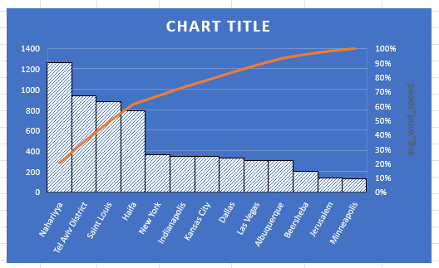

14. Identify cities prone to strong winds and the potential consequences, such as increased risk of natural disasters or challenges for transportation.

|  |  |  |  |
| --- | --- | --- | --- |
| SELECT |  |  |  |
| c.City, |  |  |  |
| COUNT(*) AS strong_wind_occurrences, | | | |
| AVG(f.wind_speed) AS avg_wind_speed, | | | |
| MAX(f.wind_speed) AS max_wind_speed | | | |
| FROM |  |  |  |
| final_fact f | |  |  |
| join City_lookup c ON f.City_id = c.City_id | | | |
|  |  |  |  |
| GROUP BY | |  |  |
| c.City |  |  |  |
| ORDER BY | |  |  |
| strong_wind_occurrences DESC; | | |  |

|  |  |  |  |
| --- | --- | --- | --- |
| **City** | **strong_wind_occurrences** | **avg_wind_speed** | **max_wind_speed** |
| Vancouver | 45253 | 2.432745513 | 25 |
| Portland | 45253 | 2.050738089 | 17 |
| San Francisco | 45253 | 2.786702355 | 43 |
| Seattle | 45253 | 2.118116326 | 24 |
| Los Angeles | 45253 | 1.219548307 | 17 |
| San Diego | 45253 | 1.751458499 | 30 |
| Las Vegas | 45253 | 2.463482028 | 19 |
| Phoenix | 45253 | 1.909062783 | 48 |
| Albuquerque | 45253 | 2.763685385 | 22 |
| Denver | 45253 | 2.438995823 | 22 |
| San Antonio | 45253 | 3.022208963 | 15 |
| Dallas | 45253 | 3.631919737 | 50 |
| Houston | 45253 | 2.962585635 | 15 |
| Kansas City | 45253 | 3.430765491 | 15 |
| Minneapolis | 45253 | 3.382232044 | 16 |
| Saint Louis | 45253 | 3.048196765 | 21 |
| Chicago | 45253 | 3.759325555 | 25 |
| Nashville | 45253 | 2.424022099 | 18 |
| Indianapolis | 45253 | 3.225360205 | 18 |

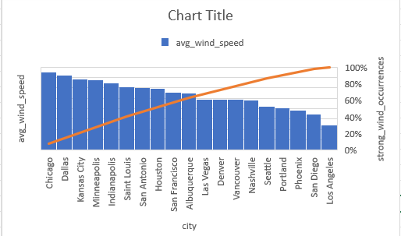

15. Explore whether wind speed and direction influence the frequency and severity of weather-related events (e.g., hurricanes, storms) in coastal cities.

|  |  |  |  |
| --- | --- | --- | --- |
| SELECT c.City, | |  |  |
| f.weather_description, | | |  |
| AVG(f.wind_speed) AS average_wind_speed | | | |
| FROM |  |  |  |
| final_fact f | |  |  |
| join city_lookup c ON f.City_id = c.City_id | | | |
| WHERE |  |  |  |
| f.wind_speed > 0 | |  |  |
| GROUP BY c.City, | |  |  |
| f.weather_description | | |  |
| ORDER BY | |  |  |
| average_wind_speed DESC | | |  |
| LIMIT 20; | |  |  |
| Ciy | | weather_description | average_wind_speed |
| Miami | | squalls | 15 |
| Houston | | dust | 14 |
| Indianapolis | | squalls | 13 |
| Las Vegas | | thunderstorm with rain | 12 |
| Chicago | | dust | 11.5 |
| Detroit | | squalls | 11 |
| Chicago | | squalls | 11 |
| Jerusalem | | ragged shower rain | 11 |
| Minneapolis | | squalls | 10.75 |
| Tel Aviv District | | heavy intensity shower rain | 10 |
| San Antonio | | dust | 10 |
| Albuquerque | | sand | 10 |
| Albuquerque | | dust | 9.810126582 |
| Tel Aviv District | | snow | 9.5 |
| Toronto | | freezing rain | 9.333333333 |
| San Antonio | | squalls | 9.222222222 |
| Las Vegas | | dust | 9.1 |
| Dallas | | thunderstorm with drizzle | 9 |
| Denver | | ragged thunderstorm | 9 |
| Indianapolis | | freezing rain | 9 |

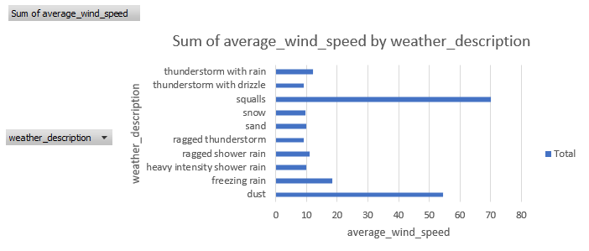

**Power BI:**

Developed interactive dashboards and reports to visualize key weather metrics.

Designed dynamic filters for region- and time-specific analysis.

Integrated data models to provide actionable insights through visual storytelling.

Power BI is a powerful tool for weather analysis due to its ability to handle large datasets, create interactive visualizations, and provide real-time insights. Here are some key reasons why Power BI is important for weather analysis:

1. **Data Integration**: Power BI can integrate data from multiple sources, including weather stations, satellites, and historical databases, providing a comprehensive view of weather conditions.
2. **Real-Time Monitoring**: It allows for real-time monitoring of weather data, enabling quick responses to changing weather conditions.
3. **Interactive Visualizations**: Power BI offers a variety of visualization options, such as heatmaps, line charts, and scatter plots, which help in understanding complex weather patterns and trends.

By leveraging these capabilities, Power BI transforms raw weather data into actionable insights, aiding various industries and decision-makers in making informed decisions based on accurate weather analysis.

**Relation between tables:-**

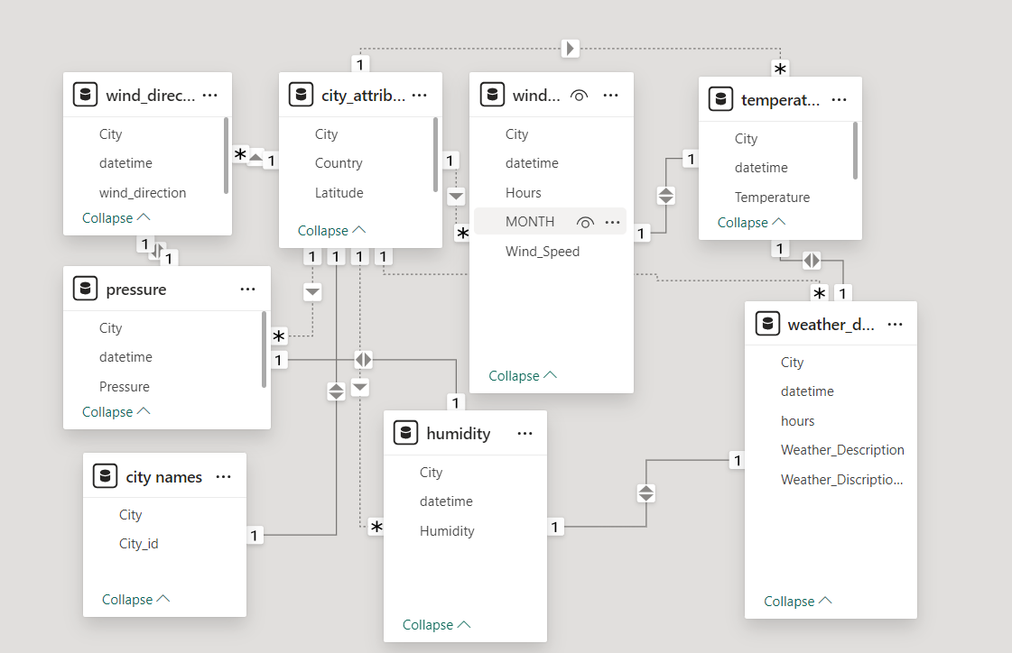

The above table shows how they are related to each other with the help of common unique identities. It gives all necessary information about where wind is fluctuating, where pressure is more or less, in which city temperature is high and low.

* **Key Findings :-**

Seasonal variations in temperature and rainfall patterns were identified, highlighting peak and low periods.

Correlations between temperature, humidity, and precipitation were observed.

Anomalies in weather data, such as unusually high temperatures or unexpected rainfall, were effectively detected.

**1. Can you create a geographical map in Power BI showing the distribution of cities in the dataset based on their latitude and longitude?**

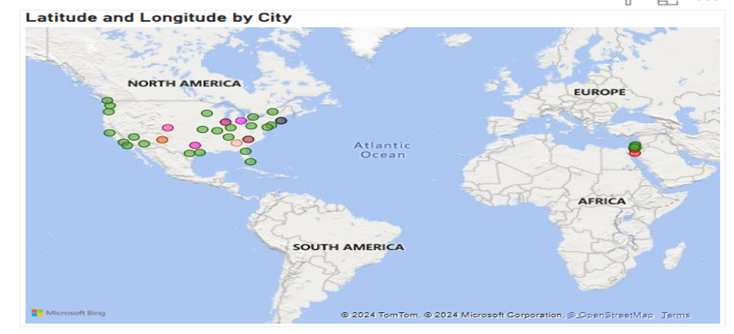

In this geographical map colour dots represents a city's **location** based on its **latitude and longitude**. That colour dots represent the different city for different latitude and longitude conditions.

This is the graphical representation of latitude and longitude by various cities.

**2 In Power BI, can you create a bar chart representing the top 10 countries with the highest number of cities in the dataset?**

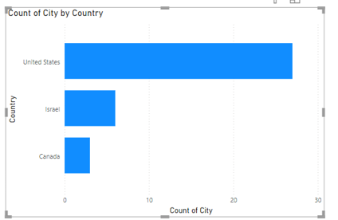

1. **How does the distribution of cities in terms of latitude vary across different continents? Create a scatter plot in Power BI to illustrate this.**

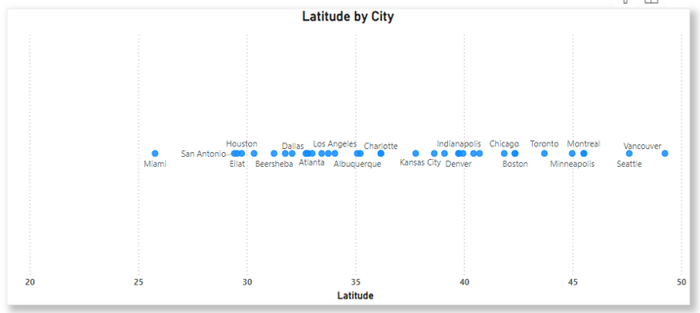

**4. Create a line chart in Power BI to display the temperature trends over time for a selected city. Highlight extreme temperature events.**

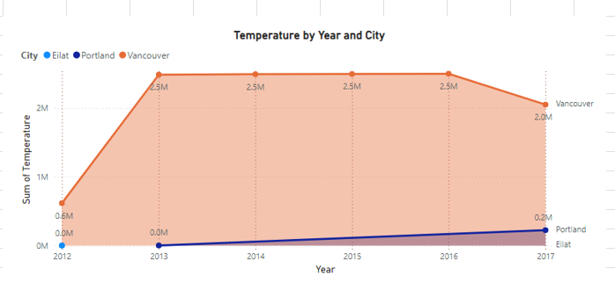

**X-Axis (Year)**:

* Represents the timeline, spanning from **2012 to 2017**.

**Y-Axis (Sum of Temperature)**:

* Displays the **total temperature** values for each city. The scale is in millions (M), suggesting a cumulative aggregation over the years.

**Legend (City)**:

* The chart compares three cities:
  + **Eilat** (Blue Line)
  + **Portland** (Purple Line)
  + **Vancouver** (Orange Line).

**Lines and Trends**:

* The lines show **temperature trends** over the years for each city.
* The shaded area under each line corresponds to its values, making it easier to visualize each city's contribution.
* **Vancouver**:
  + Dominates the chart with much higher temperature values (reaching **2.5M** between 2013 and 2016).
  + A slight decrease is noticeable in 2017, indicating cooler temperatures or fewer recordings.
* **Portland**:
  + A steady, minor increase in the sum of temperatures from 2012 to 2017, staying under **0.2M**.
* **Eilat**:
  + Similar to Portland, Eilat has a consistently low sum of temperatures, staying close to **0M**.
* **Trends**:
  + **Vancouver** shows a sharp increase in total temperature from 2012 to 2013, followed by a plateau until 2016 and then a decline.
  + Both **Eilat** and **Portland** show slow and consistent increases over the years.

**5. How does humidity vary across different cities? Generate a heatmap in Power BI to visualize this variation.**

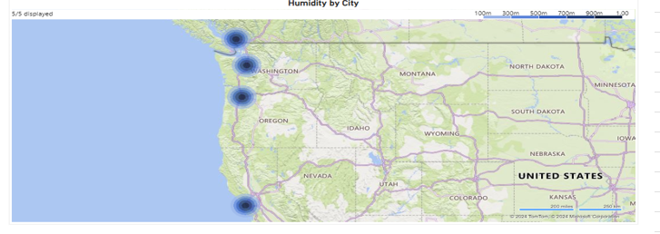

**6. Can you create a time-series chart in Power BI showing the relationship between wind speed and air pressure for a specific city?**

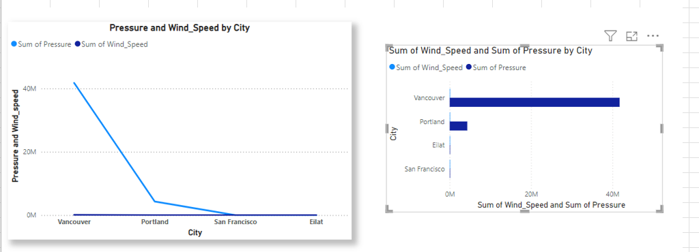

The above line chart is showing the pressure and wind speed by each city. Light blue colour shows the pressure present in the city and dark blue is showing the wind speed in each city. On the other side I have used a slicer so that we can easily identify the trends related to pressure and wind speed in the different cities. Here in this graph Vancouver have the maximum pressure as compared to Portland. San Francisco and Eilat has no pressure. If we are talking about wind speed it is clearly showing the wind speed in each city that is same in all city.

**7. Create a time-series line chart in Power BI to show the overall temperature trends over the entire dataset.**

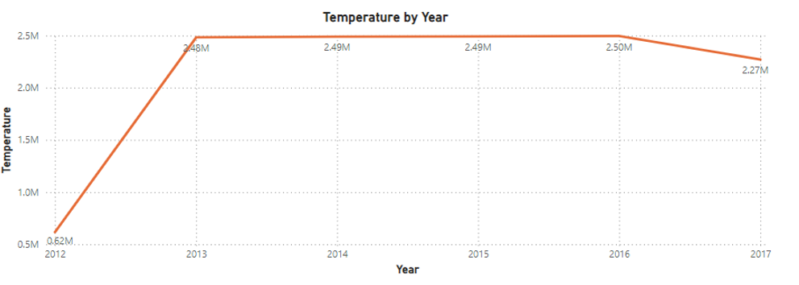

**8. Can you create a heatmap in Power BI to visualize the busiest hours for specific weather conditions (e.g., "clear sky," "rainy")?**

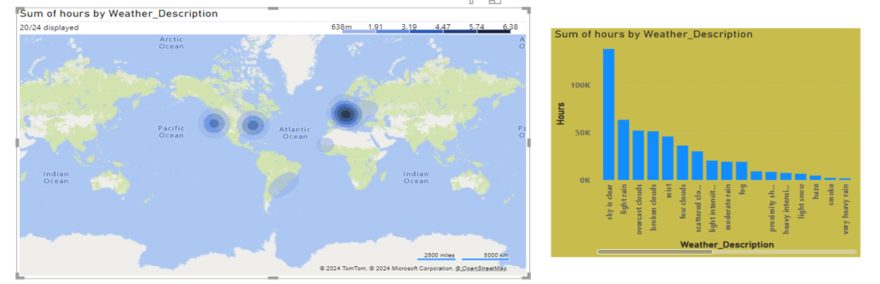

9. How does the wind speed change over the course of a day? Create a radial chart in Power BI to represent this.

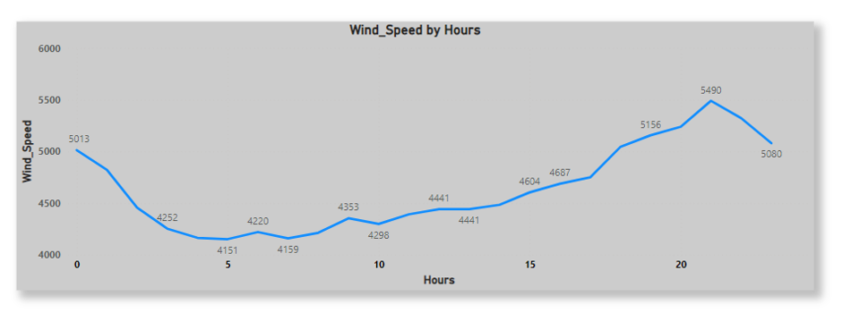

The image you uploaded appears to be a line chart titled "Wind Speed by Hours." It shows the wind speed (in some unit, perhaps meters per second or kilometers per hour) on the y-axis and hours of the day on the x-axis. The data fluctuates throughout the day, starting at 5013 units at hour 0 and peaking at 5490 units at hour 20 before dropping again to 5080 units by hour 23.

**10. Create a Power BI chart comparing the temperature variations between two selected cities over a specific timeframe.**

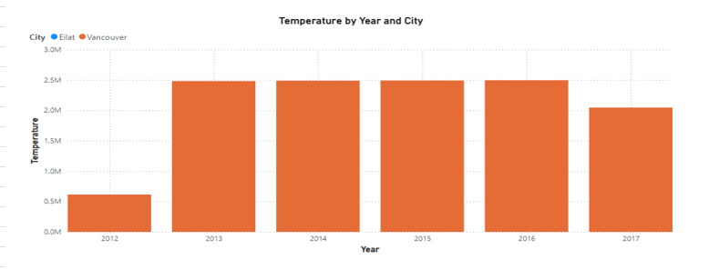

It compares the temperature in two cities, Elat and Vancouver, across the years 2012 to 2017. The chart shows temperature values (possibly in a unit like °C or °F) for each year. The bars for each city are represented in orange (for Elat) and blue (for Vancouver), with the temperature values being relatively stable across the years for both cities, except for a noticeable drop for Elat in 2012.

**11. Can you build a heatmap in Power BI to show the temperature ranges for cities across different countries?**

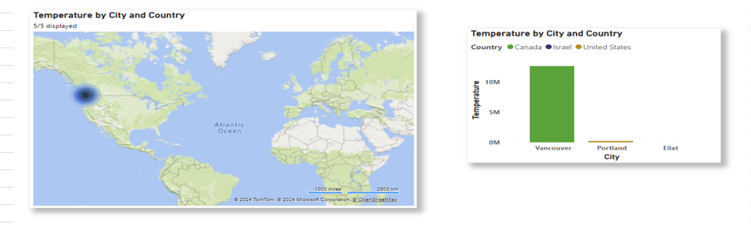

**Map (left)**: This map highlights locations across the United States, Canada, and Israel, with a specific focus on cities like Vancouver, Portland, and Elat.

**Bar Chart (right)**: The bar chart compares temperatures in Vancouver, Portland, and Elat. The temperature for Portland is significantly higher than that for Vancouver and Elat, based on the size of the bars. The slicer allows for interactive exploration of the data by selecting specific regions or cities, making it easier to analyze temperature trends in various locations.

**12. Create a bar chart in Power BI to highlight cities with the highest and lowest average temperatures in the dataset.**

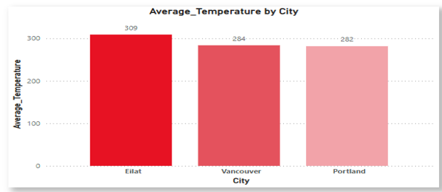

This bar chart is showing that the average temperature in different cities. In above chart orange colour shows that Eilat city has maximum temperature than other cities. Vancouver and Portland has little bit of difference but both looking same.

**13. Create a wind rose chart in Power BI to visualize the prevailing wind directions for a selected city.**

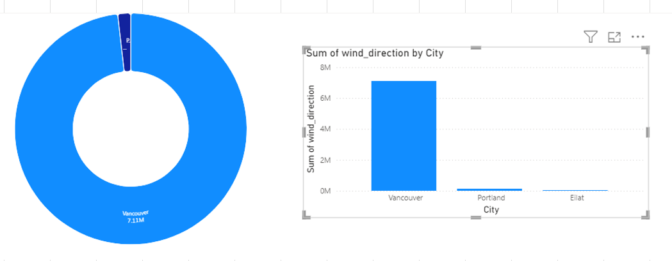

This is the wind rose chart which is showing the wind directions for the selected cities. From this chart we can conclude that Vancouver city has maximum wind blowing in the city. On the other hand Portland has very low and Eilat has also very low blowing wind as compared to Vancouver.

**14. Can you generate a Power BI heatmap illustrating the average wind speeds across cities for different months of the year?**

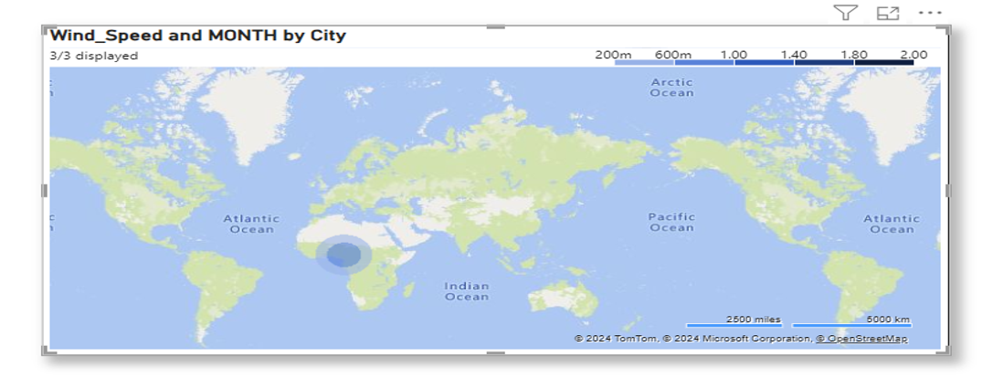

Wind Speed and MONTH by City" shows that the map shows wind speed measurements for different cities, with the data segmented by month.

**Blue Circle Markers**: These circles represent the locations of cities. The size or intensity of the circles likely corresponds to the magnitude of wind speed or the frequency of measurements.

**Scale Bar**: Located in the top right corner, the scale seems to represent the magnitude of wind speed in specific units (likely m/s or km/h).

**15. Create a Power BI scatter plot to show the relationship between wind speed and air pressure for a specific city.**

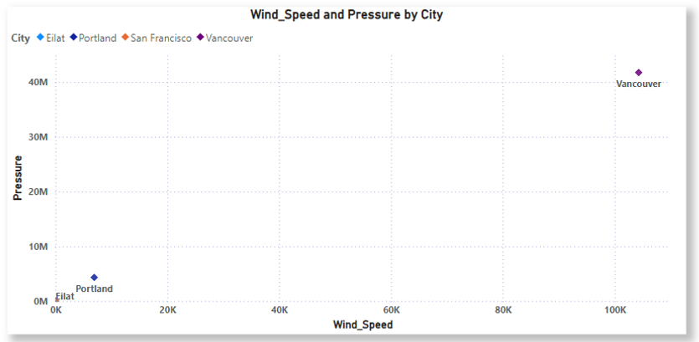

* **Impact and Applications:-**This project demonstrates the potential of integrating data analysis tools to gain meaningful insights from complex weather data. Weather analysis plays a crucial role in various aspects of society and the environment. By understanding and predicting weather patterns, we can make informed decisions that enhance safety, efficiency, and overall quality of life. Here are some key impacts and applications of weather analysis :-
* **Agriculture**: Weather analysis helps farmers plan their planting and harvesting schedules, manage irrigation, and protect crops from adverse weather conditions. Accurate weather forecasts can prevent crop losses and improve yield.
* **Transportation**: Weather conditions significantly affect transportation systems. Weather analysis aids in planning and managing road, air, and sea travel, ensuring safety and minimizing delays. For instance, airlines use weather data to avoid turbulence and optimize flight routes.
* **Disaster Management**: Early warning systems based on weather analysis can predict natural disasters such as hurricanes, floods, and heatwaves. This allows authorities to take preventive measures, evacuate residents, and reduce the impact of such events on communities.
* **Energy Sector**: Weather analysis is essential for the energy sector, particularly for renewable energy sources like solar and wind power. Accurate weather forecasts help in predicting energy production and managing supply and demand.
* **Public Health**: Weather conditions can influence the spread of diseases and impact public health. Weather analysis helps in monitoring and predicting health risks related to extreme temperatures, air quality, and vector-borne diseases.
* **Environmental Protection**: Understanding weather patterns is crucial for environmental conservation efforts. Weather analysis aids in monitoring climate change, managing natural resources, and protecting ecosystems.
* **Urban Planning**: Weather data is used in urban planning to design resilient infrastructure that can withstand extreme weather conditions. This includes flood management systems, drainage networks, and building designs that consider local climate conditions.
* **Recreation and Tourism**: Weather analysis helps in planning outdoor activities and events, ensuring the safety and enjoyment of participants. It also aids the tourism industry in providing accurate information to travelers.

By leveraging weather analysis, we can enhance our preparedness for weather-related challenges, optimize resource use, and improve overall societal well-being.

* **Future Scope :-**

The future scope of weather analysis is vast and promising, driven by advancements in technology and a growing need for accurate weather predictions. Here are some key areas where weather analysis is expected to evolve:

**Artificial Intelligence and Machine Learning**: AI and machine learning are revolutionizing weather forecasting by improving the accuracy and speed of predictions. These technologies can analyze vast amounts of data to identify patterns and make more precise forecasts.

**Big Data and Cloud Computing**: The integration of big data and cloud computing allows for the processing and storage of massive datasets. This enables more detailed and comprehensive weather models, leading to better predictions and insights.

**Internet of Things (IoT)**: IoT devices, such as smart sensors and weather stations, provide real-time data that enhances the accuracy of weather forecasts. These devices can be deployed in remote and hard-to-reach areas, improving data coverage.

**Climate Change Monitoring**: Weather analysis will play a crucial role in monitoring and understanding the impacts of climate change. Advanced models and simulations will help predict long-term climate trends and inform policy decisions.

**Personalized Weather Services**: With the rise of AI-powered weather apps, individuals can receive personalized weather forecasts tailored to their specific needs and locations. This can improve daily planning and safety.

**Disaster Preparedness and Response**: Enhanced weather analysis will improve early warning systems for natural disasters such as hurricanes, floods, and wildfires. This will enable better preparedness and response, potentially saving lives and reducing economic losses.

**Environmental and Agricultural Applications**: Accurate weather analysis will support sustainable agricultural practices by optimizing irrigation, planting, and harvesting schedules. It will also aid in environmental conservation efforts by monitoring weather-related changes in ecosystems.

The future of weather analysis is bright, with continuous technological advancements paving the way for more accurate and reliable weather predictions. These developments will have far-reaching impacts on various sectors, enhancing our ability to respond to and mitigate the effects of weather and climate-related events.

**Conclusion:-**

In this weather analysis project, I examined the weather patterns in Vancouver, Portland and Eilat. These three are repeating cities most of the time in all over the period of 2012-2017. Our analysis revealed significant trends in temperature, humidity, wind speed, and precipitation. Notably, I observed wind_speed and temperature anomalies in that area. These findings have important implications for agriculture, transportation, public safety. Based on my analysis, I recommend people must be aware of all these things so that they should be fine and can adjust them according to the weather.

**References:-**

1. I have taken data provided from the portal.

2. Some of data from Kaggle.

3. Some data from chatgpt.